50 Million Strong by 2029 | Leslie Hicks  SHAPE America Physical Activity Council  Academic Coach  Chandler Unified School District – IRC  Hick.leslie@cusd80.com
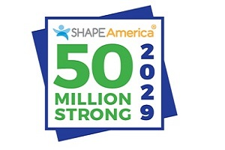
https://www.youtube.com/watch?v=PaY4x2sziTY
Approximately 50 million students are currently enrolled in America's elementary and secondary schools (grades pre-K to 12).
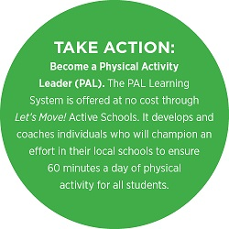
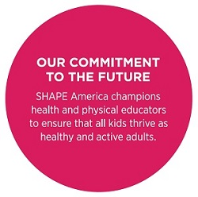
SHAPE America wants to ensure that by the time today's preschoolers graduate from high school in 2029, all of America's students are benefitting from the skills, knowledge, confidence, desire and opportunities to enjoy healthy, meaningful physical activity.

Moving Ideas Into Action
In your role as a health and/or physical educator, you are uniquely poised to deliver the benefits of living a physically active and healthy life. By coming together as a profession, we can solidify public support for health and physical education as benefitting current and future generations.

SHAPE America website - fill out the 50 Million Strong Count Me In! http://www.shapeamerica.org/prodev/50million.cfm

Register in the Let's Move! Active Schools program, take the evaluation and begin the activate and celebrate process.
http://www.letsmoveschools.org

Appropriate Instructional Practice Guidelines
http://www.shapeamerica.org/standards/guidelines/upload/Appropriate-Instructional-Practices-Grid.pdf

Physical Education Program Checklist
http://www.shapeamerica.org/standards/guidelines/upload/Physical-Education-Program-Checklist.pdf

